3D Touch Auto Leveling Sensor for 3D Printers

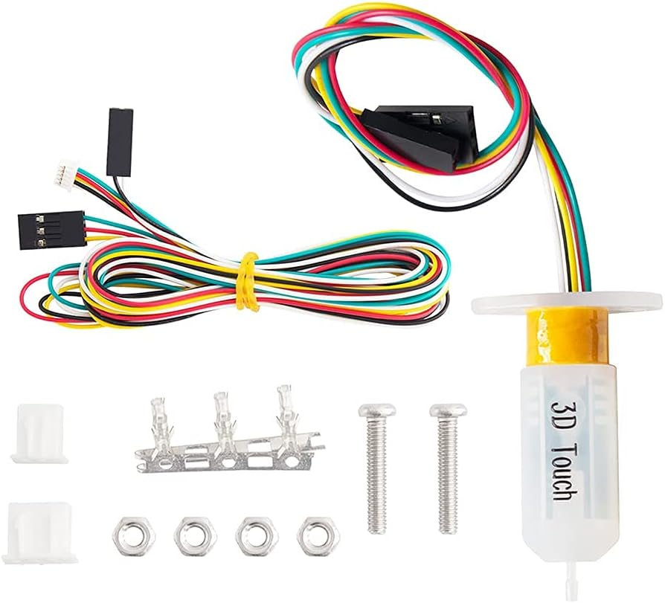

The 3D Touch Auto Leveling Sensor is an advanced and reliable bed leveling accessory designed to improve the accuracy, efficiency, and quality of your 3D printing experience. By automating the bed-leveling process, this sensor eliminates the need for manual adjustments, ensuring precise first-layer adhesion and smoother prints every time.
If you’ve ever struggled with inconsistent bed leveling or poor print adhesion, the 3D Touch sensor is the solution. Compatible with a wide range of 3D printers, it uses smart sensor technology to detect the distance between the nozzle and the print bed, providing real-time adjustments and enhancing overall print performance.

Reliable Auto Bed Leveling
At the core of the 3D Touch sensor is its ability to automatically measure and compensate for irregularities on the print bed surface. Traditional manual leveling requires time, patience, and experience, but with this sensor, the process becomes fully automated. Once installed, the sensor probes multiple points on the print bed, maps out any uneven surfaces, and communicates with the printer’s firmware to adjust nozzle height during printing. This guarantees consistent print quality, even if the bed is slightly warped or not perfectly flat.

Wide Compatibility
The 3D Touch Auto Leveling Sensor is compatible with most open-source 3D printers, including popular models such as Creality Ender series, CR-10, Anet, Anycubic, and Prusa i3 (with appropriate firmware updates). The included wiring and mounting hardware make it easy to adapt to different setups. Since it works with both glass and metal beds, it is versatile enough to suit a variety of print surfaces.

High Precision and Accuracy
The sensor is designed to deliver repeatable and accurate measurements. It detects the nozzle’s distance from the print bed within a fraction of a millimeter, ensuring perfect layer adhesion and preventing nozzle crashes. This level of accuracy is essential for professional-grade 3D printing and for producing detailed parts that require strict dimensional accuracy.

Easy Installation and Setup
The package includes everything you need for installation:
- 3D Touch Sensor unit
- Multi-colored connection cables
- Screws, nuts, and mounting accessories
- Connector terminals for secure wiring
Installation is straightforward and requires only basic tools. Once physically mounted, the sensor can be configured through your printer’s firmware (e.g., Marlin). With detailed instructions and strong community support, even beginners can set it up without hassle.

Enhanced Print Quality
One of the most common causes of failed prints is poor first-layer adhesion. With the 3D Touch Auto Leveling Sensor, this problem is minimized. The automatic compensation ensures that the nozzle maintains an optimal gap from the bed surface at all times. As a result, your prints will exhibit:
- Stronger first-layer adhesion
- Reduced warping and curling
- Improved dimensional accuracy
- Fewer failed prints
This translates into more reliable 3D printing and less wasted filament, saving both time and money.

Key Features
- Automatic Bed Leveling: Measures and compensates for bed irregularities.
- High Precision: Ensures nozzle height accuracy within microns.
- Versatile Compatibility: Works with most open-source 3D printers.
- Durable Design: Built to withstand long printing sessions and repeated use.
- Easy Installation: Comes with complete wiring and mounting hardware.
- Supports Multiple Surfaces: Functions on glass, aluminum, and other common bed materials.

Applications
The 3D Touch Auto Leveling Sensor is suitable for:
- Hobbyists who want to simplify their 3D printing process.
- Professional makers requiring consistent, high-quality results.
- Educational environments where students are learning about 3D printing.
- Industrial prototyping labs seeking efficiency and reliability.

Why Choose the 3D Touch Auto Leveling Sensor?
Manual bed leveling can be time-consuming and frustrating, often leading to print failures if not done correctly. With the 3D Touch Auto Leveling Sensor, you can eliminate guesswork and enjoy a stress-free printing experience. This affordable yet powerful upgrade provides enhanced precision, efficiency, and reliability, making it an essential accessory for anyone serious about 3D printing.
By integrating this sensor into your 3D printer, you not only improve print quality but also save valuable time and resources. It is a must-have tool for anyone looking to achieve professional-level results without the hassle of constant manual adjustments.

